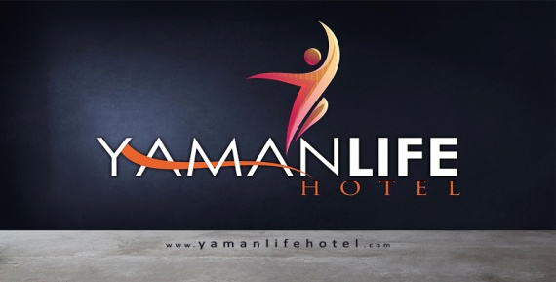

**FACT SHEET Summer 2024**

**Name of the Hotel :** **yamanlife hotel**

**Address :** Cumhuriyet Mah. Sanat Okulu Cad. No:10 / Alanya / **Antalya**

**Tel :** 0 -242- 514 40 20

**Fax :** 0 -242- 514 40 02

**Mail Address :**info@yamanlifehotel.com

**Web page :**[www.yamanlifehotel.com](http://www.yamanlifehotel.com)

**Concept :**BB

**Area located :**1.112 sqm

**Nearest city centre :**Alanya **Distance :** 1 km

**Nearest Airport :**Antalya Airport **Distance :** 119 km

**Position :**On seashore

**Total number room/bed capacity :** 44 rooms / 132 beds

**Number of blocks : 1** Main building

**Lifts :** 1 in the Main building

**Payment :** Visa, Master Card

**Pets :** Pets unacceptable

**Languages spoken :** English, German, Russian,Turkısh

**ROOM İNFORMATION LOCATİON**

* Shower & Wc < 120 km to Antalya
* Air conditioner < 1 km to Alanya
* Hairdryer < 100 mt to the center
* Led TV < 50 mt to Beach
* Mini bar ( empty )
* Telephone
* Balcony
* Free Wi – Fi
* Single Bed Size

155*215 cm

* Double Bed Size

195*215 cm

**ROOM CATEGORIES and DETAILS**

**Standard economy Room :** Total 8 standard rooms vary from 25 sqm. It is the room category with twin bed or french bed formed by a room and a Bath / Wc. Maximum capacity of the rooms is 2 persons.

**Standard Triple Room :** Total 36 Standard triple rooms vary from 25 sqm. It is the room category with French bed and 1 sngl bed formed by a room and a Bath / Wc. Maximum capacity of the rooms is 3 persons.

.

**Linens:** Change in every 3 day **Towels:** Change in every 3 day

**Rooms:** Are cleaned every day

**FOOD and BEVERAGE PRESENTATION**

|  |  |  |  |
| --- | --- | --- | --- |
| BREAKFAST ALTERNATIVES | **HOURS** | **PLACE** | **PRESENTATION** |
| Breakfast (main restaurant ) | 08.00-10.00 | Main Restaurant | Open Buffet |

**BARS**

|  |  |  |
| --- | --- | --- |
| BEVERAGE SERVICE | **HOURS** | **PRESENTATION** |
| Services Bar | 10:00-00.00 |  |

###### HOTEL SERVICES and SPORT ACTIVITIES

**Drinks (with charge):** Drinks imported from borders, local and imported special wines, champagne and fresh fruit juices, Turkish coffee, all alcoholic and non alcoholic imported and local drinks

**Free Hotel Services:** Outdoor parking area, Free Wi-fi at the Lobby, restoran ,pool area

**Hotel Services (charged) :** Fax, telephone, renting car, laundry, dry, doctor and nurse (24 hours available), massage, theraph ,coiffeur, Safe

**POOL**

|  |  |
| --- | --- |
|  | **AREA / sqm** |
| Outdoor pool | 160 sqm |
| Outdoor pool for kids | 6.40 sqm |